Aquatic Invasions manuscript AI15-039 second revised version 1 December 2015
Research article

Alien macroinvertebrates in Flanders (Belgium)

Pieter Boets^{1,2,*}, Dimitri Brosens³, Koen Lock¹, Tim Adriaens³, Bart Aelterman³, Joost Mertens⁴, Peter L.M. Goethals¹
¹Laboratory of Environmental Toxicology and Aquatic Ecology, Ghent University, J. Plateaustraat 22, B9000 Ghent, Belgium
²Provincial Centre of Environmental Research, Godshuizenlaan 95, B9000 Ghent, Belgium
³Research Institute for Nature and Forest (INBO), Kliniekstraat 25, B1070, Brussels, Belgium
⁴Vlaamse Milieumaatschappij, Afdeling Rapportering Water, Team meetnetten oppervlaktewater Dender, Bovenschelde en Gentse kanalen. Raymonde de Larochelaan 1, B9051 Sint-Denijs-Westrem, Belgium.

*corresponding author
email: pieter.boets@oost-vlaanderen.be
tel: +32472521819
email co-authors: dimitri.brosens@inbo.be, koen_lock@hotmail.com, tim.adriaens@inbo.be, j.mertens@vmm.be, peter.goethals@ugent.be
Abstract
Biological invasions of aquatic macroinvertebrates are gaining interest because of their potential for significant ecological and socio-economic impacts (positive and negative). In the present study, an inventory was made of the alien macroinvertebrates occurring in Flanders (northern Belgium) based on extensive existing collections of biological samples and supplemented with our additional sampling programs. Fresh and brackish waters as well as the Belgian coastal harbours, situated at the interface of the marine environment, were investigated. Over 2,500 samples containing alien macroinvertebrates were identified to species level, which allowed us to accurately map their distribution in Flanders. Alien macroinvertebrates are widespread and abundant in many watercourses in Flanders. Four new macroinvertebrate species for Flanders were discovered: Procambarus clarkii (Girard, 1852), Echinogammarus trichiatus (Martynov, 1932), Synurella ambulans (F. Müller, 1846) and Laonome calida Capa 2007. Fifty-two alien macroinvertebrates were encountered in fresh and slightly brackish surface waters, and 21 alien species were reported for the Belgian part of the North Sea and its adjacent estuaries. Most alien macroinvertebrates collected were crustaceans and molluscs. Alien species found in fresh and brackish water mainly originate from the Ponto-Caspian area and North America; fewer species originated from Asia and South- and East-Europe. The major pathways were probably shipping and dispersal through canals. Based on observations in neighbouring countries, several additional species are expected to arrive in the near future. Follow-up work is needed to assess the ecological and economic impacts of existing alien macroinvertebrates, and a monitoring program is needed to detect new incoming species.

Key words: alien invasive species, Crustacea, Mollusca, distribution, Global Biodiversity Information Facility
Introduction
During the last century, an increasing number of alien species has been observed colonizing aquatic ecosystems worldwide. Although migration of species can be considered as a natural process, anthropogenic influences have altered the geographic scale, speed, and dispersal mode of invaders (Elton 1958, Crooks 2002). In Europe, the majority of the alien macroinvertebrates are found in fresh- and brackish water ecosystems which are crustaceans and molluscs from North-America and the Ponto-Caspian basin (Bij de Vaate et al. 2002, Leppäkoski et al. 2013; Nunes et al. 2015).
Because of the growing number of non-native colonizers, and the ecological and economic consequences they can cause, biological invasions have received increasing attention during the past few decades. As a result, the number of publications, workshops, congresses and journals about alien species increased substantially (Pyšek et al. 2006). In contrast to other countries and Wallonia (the southern region of Belgium) (Vanden Bossche et al. 2001, Vanden Bossche 2002, Josens et al. 2005), the occurrence and spread of alien macroinvertebrates are poorly known in Flanders. Wouters (2002) showed that at least 13 macrocrustaceans had invaded Belgium while Vandepitte et al. (2012) study of marine and brackish waters in Flanders listed over 40 alien macroinvertebrate species including crustaceans, molluscs and worms. The proximity of the sea, the interconnection of different waterways, the high degree of canalisation, and the presence of several harbours make Flemish watercourses susceptible to aquatic invasions.

In this study, we mainly focused on alien macrocrustaceans since these represent, together with molluscs, the most important share of alien macroinvertebrates in many rivers across Europe (Bernauer and Janssen 2006; Gollasch and Nehring 2006; Messiaen et al. 2010). We present an inventory of alien macroinvertebrates in Flemish watercourses and investigate the temporal and spatial extent of such invasions. We collated data from various existing sources and complemented this with targeted surveys. The resulting dataset can be used for further research or management of aquatic alien macroinvertebrates and is especially useful in light of the new European Regulation on the prevention and management of alien invasive species (EU 2014). This legislative tool requires member states to: prevent introductions of alien species of concern; to survey and rapidly detect those species; and to subsequently eradicate, contain, or manage them in an adequate manner (Genovesi et al. 2015). Also, the species registry presented here contains information on origin, date of first introduction, and pathways and can therefore be used to complement existing authoritative databases on species introductions such as Delivering Alien Invasive Species In Europe (DAISIE), The European Network on Invasive Alien Species (NOBANIS) or the European Alien Species Information Network (EASIN) (Katsanevakis et al. 2012, 2013) or relevant regional species registers (e.g. Zieritz et al. 2014). Such basic species lists with information on dates and pathways are an essential basis for research and concerted action on tackling biological invasions (Roy et al. 2014, Essl et al. 2015). Data were published through the Global Biodiversity Information Facility (GBIF) under a creative commons license so as to maximize their potential for research and management of invasive alien species (IAS) (Groom et al. 2015).

Materials and Methods
Study area
Our study was conducted in Flanders (northern Belgium), which is situated in Northwest Europe and is bordered to the northwest by the North Sea (Figure 1). The bounding coordinates for Flanders are: 50.68 to 51.51 latitude and 2.54 to 5.92 longitude. Flanders comprises an area of 13,500 km², is highly urbanised, and is characterized by a high population density (on average 460 inhabitants km⁻²) (Vanweddingen 2012). The region is classified as lowland and has a dense network of small and large watercourses that includes an extensive network of navigable canals (over 1000 km). The dominant land uses are agriculture, industry, and residential. The landscape typically consists of a highly fragmented and complex mosaic of different forms of land use (Poelmans and Van Rompaey 2009). This imposes a high pressure on semi-natural biotopes with habitat fragmentation and habitat quality loss as the major drivers of biodiversity loss in Flanders (Dumortier et al. 2007). Different aquatic habitats were monitored including all types of watercourses (Jochems et al. 2002), lakes, and (coastal) harbours.

Data collection
Species were classified as alien based on the definition used by the Convention on Biological Diversity (CBD, Decision VI/23) stating that alien species are those species, subspecies, or lower taxa that are deliberately or unintentionally introduced by human action outside their natural past or present distribution. Only (hyper)benthic macroinvertebrates were considered in this study. Sessile fauna and Ctenophora were not included in this analysis since they were not the focus of this research and require a different sampling strategy. Different sources of data were available:
Flemish Environment Agency: Data collected by the Flemish Environment Agency (VMM; Figure 2) at 4,600 different sampling locations situated in inland waters (fresh and brackish water). A fixed set of sampling locations was sampled every three years, whereas most sampling locations were only sporadically sampled, resulting in a large dataset of more than 11,000 biological samples collected between 1989 and 2012. The samples are stored at the Royal Belgian Institute of Natural Sciences (RBINS). Since samples of the VMM are identified to genus or family level, information about alien macrocrustacean species such as Dikerogammarus villosus (Sowinsky, 1894) or Gammarus tigrinus Sexton, 1939 was not available, since both species belong to the Gammaridae, as does the native Gammarus pulex (Linnaeus, 1758). Consequently, we further identified 2,500 samples to species level. Although we try to give a complete overview of all alien macroinvertebrates encountered in Flanders, here, we only identified macrocrustaceans, molluscs, and Platyhelminthes to species level.

Depending on the depth of the watercourses, macroinvertebrates were sampled by means of a standard handnet or the use of artificial substrates (Gabriels et al. 2010). The handnet consists of a metal frame of approximately 0.2 m by 0.3 m to which a conical net is attached with a mesh size of 300 µm. With the handnet, a stretch of approximately 10-20 m was sampled during three minutes for watercourses less than 2 m wide or five minutes for larger rivers. Sampling effort was proportionally distributed over all accessible aquatic habitats. In addition to the handnet sampling, macroinvertebrates were manually picked from stones, leaves or branches along the same stretch (Gabriels et al. 2010). Artificial substrates consisting of polypropylene bags (5L) filled with bricks of different sizes, were used for deep waters like canals, where handnet sampling was not possible (Gabriels et al. 2010). Three replicates of artificial substrates were left in the water for a period of at least three weeks before being retrieved. This way, species had the time to colonise the substrates. Both sampling methods represent standardised semi-quantitative methods (Gabriels et al. 2010).

New samples: We collected samples during 2008-2012 at various locations where alien macroinvertebrates species were expected to occur based on historical records, information retrieved from databases or observations made by colleague zoologists. The same method as applied by the VMM was used to collect these samples. Samples also were collected during a survey of the Belgian coastal harbours to assess the diversity and abundance of alien macrocrustaceans (Malacostraca) (Boets et al. 2012a).

When investigating the macroinvertebrate fauna of the Belgian coastal harbours we also used a plankton net with a circular diameter of 100 cm, a length of 3 m, and a mesh size of 200 µm. This sampling method was used for qualitative analysis only, and the samples were used to assess the species present in the water column between 0.2 m and 1.2 m above the bottom. This sampling technique was used to detect mobile taxa such as mysids that are often missed when using a handnet or artificial substrates. The plankton net was towed behind a zodiac for 10 minutes at an average speed (4 km h⁻¹ relative to the bottom). Sampling was done at predetermined, fixed, sampling locations within the harbour. All samples were taken during daytime when hyperbenthic organisms are concentrated near the bottom (Boets et al. 2012a). Samples were preserved in the field with Norvanol, transported to the laboratory of Environmental Toxicology and Aquatic Ecology and sorted. Afterwards the samples were determined to species level using several identification keys (e.g. Chapman 2007)

In order to be able to give a representative overview of the distribution of crayfish in Flanders, we not only used the standard sampling techniques as described by Gabriels et al. (2010), but also used fyke nets (0.25 m diameter and a length of 0.50 m) specifically designed to catch crayfish with bait (cat food). Historical records as well as recent observations of crayfish were checked from October 2010 to May 2011 (Boets et al. 2012b). Finally, data retrieved from a survey assessing the distribution of freshwater crayfish in Flanders (Boets et al. 2012b) was added.

Historic collections: We also checked data from the RBINS collections and from the literature reporting on the occurrence of alien macroinvertebrates (Figure 2).

Pathways
Information about the origin of the species, pathways of introduction and the first occurrence in Flanders were retrieved from different literature sources (including scientific and grey literature). For the classification of pathways of introduction, the framework described in Hulme et al. (2008) and adapted by Katsanevakis et al. (2013) distinguished five pathways: commodities intentionally released or escaped (e.g. aquarium trade); contaminants of commodities (e.g. aquaculture); stowaways on modes of transport (e.g. shipping); exploitation of corridors resulting from transport infrastructures (e.g. man-made canals) or unaided dispersal. Each pathway may be associated to a number of vectors (e.g. shipping includes vectors as ballast water and hull fouling). For simplicity and consistency with Katsanevakis et al. (2013), we used five pathways of introduction: shipping, aquaculture, corridors, aquarium trade, and others. A sixth category “unknown” was added for those species where there was doubt about which pathway explains the occurrence of the species.

We assessed the (un)certainty of a pathway using the approach proposed by Minchin (2007) and Katsanevakis et al. (2013). The following categories were used:
- Certain: there is direct evidence of a pathway/vector. There is a clear link between the pathway and the introduction of the species at a certain time. This is mostly the case for intentional introductions.
- Most likely pathway/vector: this applies to species that occur at a location where a single vector is known to operate. This is mainly the case for species introduced via shipping or aquarium trade.
- Uncertain: one or more possible pathways; the species cannot be related to one single pathway or vector.
The first occurrence in Flanders was inferred from literature, but is difficult to ascertain for unintentional or undocumented intentional introductions. The first date of observation or first report of the species in literature was used as the best proxy of the year of first occurrence. We plotted the number of new species introduced per twenty year time interval starting from in the 1600s.
We produced a distribution map, representing the number of alien species per 5 × 5 km square and a heat (hot spot) map of macroinvertebrate invasions, based on the geographic clustering of alien species occurrences in Flanders. The map was created by interpolating discrete points to a continuous surface (Kernel Density Estimate method). Areas of greater color intensity indicate a higher density of occurrence. The map shows the kernel density estimate of observed data points in geospatial coordinates. We used the cartoDB torque aggregation function to aggregate the occurrence dots (www.cartoDB.com).

Dataset description
The occurrence data from the original alien macroinvertebrate dataset were pre-processed using open.refine (http://www.openrefine.org/) and cartoDB (www.cartoDB.com) before being imported in Recorder6 (http://www.recorder6.info/) at the Research Institute for Nature and Forest (INBO). By creating a custom SQL view, the data were standardized to Darwin Core (Wieczorek et al. 2012) and were published as open data through the Global Biodiversity Information Facility (GBIF) Integrated Publishing Toolkit (Robertson et al. 2014) at INBO (http://data.inbo.be/ipt) (for the terms of use see Appendix 1). The occurrence dataset is available at: http://dataset.inbo.be/alien-invertebrate-occurrences.

Results
Taxonomic coverage: alien macroinvertebrates
Seventy-three alien macroinvertebrate species have been collected in Flanders of which 52 are regularly encountered in fresh and/or slightly brackish waters (Table 1). The remaining 21 species are restricted to the marine environment for at least a considerable share of their lifetime. Most alien macroinvertebrate species were crustaceans (51%), followed by molluscs (27%), annelids (19%) and platyhelminths (3%) (Figure 3). Most alien macroinvertebrates originate from North America (37%) or the Ponto-Caspian region (21%) (Figure 4). The main vector of introduction is probably passive transport via the hull of ships (biofouling) and ballast water (62.5%). The transport via canals is the second main vector (26.4%) and promoted the dispersion of alien macroinvertebrates. Also, some species were introduced through aquaculture (13.9%) and hobbyists (5.6%) (Figure 5).
During the last twenty years, an exponential increase in the number of established alien species has been observed (Figure 6). Before 1950, the number of aquatic alien macroinvertebrate species encountered was quite low, whereas after the 1950s, many alien macroinvertebrates were found in Flemish watercourses. Since 2000, 24 alien species were newly recorded in Flanders including four species first detected during this study: Procambarus clarkii (Girard, 1852), Echinogammarus trichiatus (Martynov, 1932), Synurella ambulans (F. Müller, 1846) and Laonome calida Capa 2007.
Hotspots for invasion of alien macroinvertebrates include the canals in the eastern parts of Flanders, the harbours, and the polder watercourses (Figure 7). Regions with a high number of species often also showed a high number of records of alien macroinvertebrates (Figure 8). The border area with the Netherlands shows a high diversity of such species, while the southern part of Flanders exhibits a lower diversity of alien species. Many species were recorded for the first time in the canals in the eastern part of Flanders. An online overview of the distribution of all alien macroinvertebrates discussed in this paper can be found at http://lifewatchinbo.github.io/alien-macroinvertebrates/.
Taxonomic coverage: macrocrustaceans and molluscs
Crustaceans represented half of all alien species (37 species), followed by alien molluscs (20 species). Most of the species were frequently found in the samples of the VMM. Especially in freshwater, the number of alien crustaceans was high (21 species) compared to the number of native species (3 species). Two important and successful amphipods that widely occur in Flanders in fresh and brackish water are Gammarus tigrinus Sexton, 1939 and the killer shrimp Dikerogammarus villosus (Sowinski, 1894). The killer shrimp has been spreading quickly since its introduction in 1997, especially in large rivers and canals that have a hard, non-natural, bank structure (Boets et al. 2010). Gammarus tigrinus was first recorded in 1991, is now widespread, and can reach high densities in canals and brackish polder watercourses (Boets et al. 2011).

Four species of alien freshwater crayfish were found in this study. The Turkish crayfish (Astacus leptodactylus Eschscholtz, 1823), originating from Eastern Europe, was found for the first time in Flanders in 1986 (Gerard 1986). The species was originally introduced to supply the natural stock but seemed vulnerable to the crayfish plague and did not have the expected yield (Pérez et al. 1997). The signal crayfish (Pacifastacus leniusculus (Dana, 1852)), recorded for the first time in Flanders in 1979 (Gerard 1986). Although P. leniusculus is a successful invader elsewhere in Europe (Kozák et al. 2015), it has a limited distribution in Flanders: it was only recorded in one pond in the East of Flanders. The spiny-cheeked crayfish (Orconectes limosus (Rafinesque, 1817)), originating from North-America, was captured for the first time in Flanders in 1977 (Wouters 2002). O. limosus has a wide distribution in Flanders and occurs in almost all river types. Currently, it is the most frequently recorded species in Flanders. The most recently introduced species is the red swamp crayfish (Procambarus clarkii), which was found in 2008 in a pond in Zammelsbroek, a nature reserve in the Eastern part of Flanders (Boets et al. 2009). Currently the species has been recorded at several locations in Flanders in ponds as well as small canals and rivers (Boets et al. 2012b). This indicates that the red swamp crayfish is spreading rapidly, possibly due to its ability to disperse over dry land.

Crabs are another group of alien species often representing high abundances and high biomass. The best-known alien crab species is the Chinese mitten crab (Eriocheir sinensis (H. Milne-Edwards, 1853)). This species has been recorded since 1933 (Wouters 2002) and occurs in several locations throughout Flanders. Although the mitten crab can reach very high densities, it was only sporadically found in the samples of the Flemish Environment Agency, probably due to the applied sampling technique that is not designed to catch this species. In the marine environment, Hemigrapsus takanoi Asakura and Watanabe, 2005 and H. sanguineus (De Haan, 1835) were regularly encountered. These two species are spreading during the last ten years and it is expected that they compete for food and habitat with the native green crab (Carcinus maenas (Linnaeus, 1857)). Another crab species which is regularly reported from marine (Nieuwpoort) as well as inland harbours (Ghent and Antwerp) and which seems to be spreading in European waters is Rhithropanopeus harrisii (Gould, 1841) (Roche and Torchin 2007).

Besides crustaceans, many alien mollusc species were found in the samples. The most frequently found species were the New Zealand mud snail (Potamopyrgus antipodarum J.E.Gray, 1843) and the acute bladder snail (Physella acuta (Draparnaud, 1805)). Potamopyrgus antipodarum is a species that occurs at high abundances in brackish polder watercourses, while P. acuta mainly occurs in freshwater streams. A high reproductive ability and a high tolerance towards environmental pollution promote its fast spread. In polluted rivers, it is often the only mollusc species recorded. Zebra mussels (Dreissena polymorpha (Pallas, 1771)) dominate large rivers and canals. This species attaches to hard substrates and can reach very high densities causing fouling problems. Its relative, the quagga mussel (D. rostriformis bugensis Andrusov, 1897) is rapidly colonising watercourses in Flanders and seems to out-compete the previously successful zebra mussel (Marescaux et al. 2015).

Discussion

Established species and alien macroinvertebrates on the horizon

The present study, which compiled data from various existing sources complemented with own surveys, reveals that more than 60 alien macroinvertebrate species occur in Flemish watercourses. Moreover, our study revealed that at least 30 alien crustacean species are present in surface waters in Flanders. Especially in freshwater, the number of alien crustaceans is relatively high compared to the number of native species recorded. One species, the native crayfish Astacus astacus (Linnaeus, 1758), went extinct in Flanders and is highly threatened in the southern part of Belgium and the rest of Europe due to the crayfish plague, habitat deterioration, and a decrease in water quality (Boets et al. 2012b). Four alien crayfish species currently occur in Flanders, of which Orconectes limosus is the most abundant and widespread. Orconectes limosus appears not to be as sensitive to land use changes and human activities as the native crayfish species (Schulz et al. 2002), and it can thrive in habitats such as soft substrates, turbid and muddy waters, polluted canals, and organically enriched ponds and lakes (Miklós 2009, Pucky 2009). Since 2009, P. clarkii has been found in Belgium and it is expected that this species can become the next dominant crayfish species because it is known to outcompete other crayfish (Gherardi 2007). P. clarkii is known to contribute to biodiversity loss and habitat degradation in several freshwater systems of south central Europe (Gherardi and Acquistapace 2007) and is therefore also expected to have negative impacts on aquatic communities in Flanders.

Besides crayfish, there are several alien species of amphipods. The best known invasive amphipod is the killer shrimp (Dikerogammarus villosus). This species, originating from the Ponto-Caspian area, started its colonisation in Flanders in the Albert canal in 1997. Due to the hard bank structures and stony substrates present in canals and large watercourses in Flanders, the species quickly dispersed (Messiaen et al. 2010). Although the range expansion of D. villosus may be influenced by many factors including hydrological regime, temperature, salinity, water quality, and food availability (Josens et al. 2005; Devin et al. 2003; Messiaen et al. 2010), habitat heterogeneity and substrate type in particular may play a crucial role in its dispersal. Detailed research on this species based on data-driven models indicates it mainly prefers large rivers and canals with a hard bank structure and a relatively good water quality (Boets et al. 2010; 2013). Where the species arrived, it always replaced the native G. pulex and in some cases the alien G. tigrinus (Messiaen et al. 2010). The effect of D. villosus on other amphipods could also be observed in neighbouring countries including the Netherlands (Van der Velde et al. 2000, van Riel et al. 2006) and France (Devin et al. 2005). Many studies show that this ‘killer shrimp’ can prey upon a diverse array of macroinvertebrate species, including native and other previously successful invasive amphipods, as well as on fish eggs and larvae (van Riel et al. 2006, MacNeil et al. 2013).

In the marine environment, the number of alien macrocrustaceans was quite limited and their distribution remained mostly restricted to the main coastal harbours or the Scheldt estuary. Many of the marine and brackish species were only recently discovered in Flanders. Whereas the number of newly discovered alien invertebrate species in freshwater has been levelled off, there are still many alien marine invertebrates establishing (Hulme et al. 2009a). With four species, Decapoda represented an important part (in terms of biomass) of the alien fauna found in the brackish and marine environment (Boets et al. 2011). Most larvae of Decapoda can be easily transported via ballast water of ships, which allows them to easily disperse not only between European countries, but also within Flanders.

Although almost all known alien macrocrustaceans and some new alien species for Flanders were found during this study (Table 1), some species were less frequently captured than others. First, some of these species have a limited distribution with only few established populations present in Flanders. Second, the sampling techniques being used are not always effective to capture mobile or large-bodied taxa such as crabs, mysids, and crayfish. The sampling method can have an impact on the assessment of the distribution of certain invaders such as E. sinensis, Hemimysis anomala G.O Sars 1907, Limnomysis benedeni Czerniavsky, 1882 and Orchestia cavimana Heller, 1865. Based on the review by Wouters (2002), E. sinensis is widely distributed in Flanders. This species can have a large impact on the environment due to its burrowing activities, and predation on and competition with native biota, including plants (Herborg et al. 2007). The limited occurrence of this species in the dataset of the VMM is most probably a consequence of the sampling method. The species is difficult to catch with artificial substrates since the organisms are highly mobile both on land and in the water. Therefore, other sampling techniques, e.g. fyke nets would give a more accurate picture of its actual distribution (http://www.gbif.org/dataset/258c9ce5-1bda-4001-a192-347c9e7fb186). Invaders like H. anomala, L. benedeni and O. cavimana are not often observed, which is probably also due to the sampling method (artificial substrates and handnet), since H. anomala and L. benedeni are fast swimmers, while O. cavimana lives on the river banks in fresh and brackish waters (Josens et al. 2005). Additional sampling of the river banks and stone sampling might reveal that the latter species is more abundant than currently-used sampling techniques suggest, while a hyperbenthic sledge would be a good sampling device to sample mysid shrimp. The application of a Multiplate Hester-Dendy Sampler could also be a good tool for standardized monitoring (Kirk and Perry 1994) and trials are currently carried out in Flanders to set out such a monitoring network.

Crustacean invaders such as Dikerogammarus haemobaphes (Eichwald, 1841), which has already invaded the Meuse (Josens et al. 2005) and Echinogammarus ischnus (Stebbing, 1899) (Wouters 2002), Orconectes immunis (Hagen, 1870) and Chelicorophium robustum (Sars, 1895), which have already invaded the Rhine (Bernauer and Janssen 2006), can be expected to arrive in Flanders soon. Also the Northern crayfish Orconectes virilis (Hagen, 1870), the Marbled crayfish and the White river crayfish Procambarus acutus (Girard, 1852) / zonangulus Hobs and Hobs, 1990, which have already been reported in the Netherlands (Koese 2008), can be expected in the near future. However, their spread will largely depend on competition with the species that are already present (Kley and Maier 2006). Recently, another species, the mud crab Dyspanopeus sayi (Smith, 1869), was recorded in the Seudre Estuary in France and has the potential to invade neighbouring countries, including Belgium (Aubert and Sauriau 2015). A recent horizon scanning exercise for the north sea region also identified Potamocorbicula amurensis and Asterias amurensis as marine alert list species (Gallardo et al. 2015b). Continuous monitoring of new and established invaders is necessary, in particular regarding their habitat preferences and their effect on native species, to obtain a better understanding of their impact due to competition and predation. Moreover, migration models can be relevant to make better predictions regarding the migration speed of alien macroinvertebrates in rivers (Gallardo et al. 2012, Boets et al. 2013).

Spatial patterns, pathways of introduction and trends of establishment

Most alien macroinvertebrates were encountered in the canals in the eastern part of Flanders and in the coastal harbours, which can be considered hotspots for alien species. Research has indicated that proximity to harbours and the connection of watercourses can to a high extent explain the spatial patterns of alien species and thus indicate which areas are prone to invasion (Gallardo et al. 2015a). Most alien macroinvertebrates were discovered for the first time in the east of Flanders, after which they gradually dispersed to the west. The close proximity and connection with large rivers such as the river Meuse and river Rhine could explain why this region is characterized by a high number of species and occurrences of alien macroinvertebrates (Figure 8). The large network of canals and its numerous connections probably promoted the further spread.

Despite some uncertainty on the pathways of introduction, shipping and man-made canals were probably the two most important ones. Many species are transported overseas via hull-fouling or ballast water of ships. Once alien species are introduced in a harbour they can easily disperse via inland waterways such as canals. Both pathways (shipping and corridors) can be related to the most important donor regions: North America and the Ponto-Caspian region. Most marine species originate from North America and were probably introduced via long distance shipping. For freshwater species the Ponto-Caspian region can be considered an important donor region. For the latter, dispersal via canals an inland shipping has shown to be an important pathway (Bij De Vaate et al. 2002). Although we investigated both the freshwater and marine environment our results are similar to Katsanevakis et al. (2013) who found that for European seas more than 50% of all alien species were probably introduced via shipping. Our results support the idea that the implementation of the Ballast Water Convention and strict regulations on trade are important to reduce the introduction and future spread of alien macroinvertebrates. With the recent ratification of the ballast water convention by Flanders, all Belgian regions have now ratified this convention and ratification by Belgium as a member state is therefore envisaged shortly.

Despite some regulations (e.g. Regulation (EC) No 708/2007), a strong increase in the number of alien macroinvertebrates has been observed for Flanders during the last 20 years, with almost 4 times as many new species established during that period compared to previous time periods. A similar increase in the number of alien species recorded has been observed on a European scale. The enormous increase in alien species that have been recorded is mainly a result of the increasing globalization (Meyerson and Mooney 2007, Hulme et al. 2009a). Increased trade and new technological developments allowing larger cargo vessels promote the spread of alien species. Moreover, changing environmental conditions (e.g. increasing temperature) and the improvement in chemical water quality, especially in freshwater environments, also contributes to the establishment and spread of alien macroinvertebrate species (Boets et al. 2013).

Impact assessment and management of alien macroinvertebrates

Alien species are not mentioned specifically in the European water framework directive (WFD; European Community, 2000). However, the precautionary principle in the broad sense is applicable with regard to the negative effects of alien species, because aquatic ecosystems have to be protected from decline. Alien species may modify the native biological structure and ecological functioning of aquatic systems and the assessment of alien species as a biological pressure should therefore be considered as a part of a catchment management policy together with other pressures. However, effective control measures to eradicate established alien aquatic macroinvertebrates often are not available and at best only slow down their expansion. Control measures can also cause additional damage through non-target effects (e.g. application of pesticides) or impose additional risks (e.g. introduction of natural predator of alien species). The Belgium Forum on Invasive Species (www.http://ias.biodiversity.be/) proposes a system of lists, based on the ability of a species to disperse, invasion status, and environmental impact (Vanderhoeven et al. 2015). It is suggested that this list can be used to select species for further extensive risk assessment with the aim to impose a ban in import, trade, and introduction in the natural environment and to prioritize species for eradication or control. In such a system, it is necessary to demonstrate significant damage before a species is listed (currently no alien macroinvertebrates are listed). However, by the time damage can be demonstrated, the considered species is usually well established in the area, and not much can be done to stop its further spread. In our opinion, preventive measures, such as the obligatory treatment of ballast water and controlled trade, are the only possible solutions to reduce the influx of alien aquatic macroinvertebrates. Thus, with regards to alien invaders of freshwater habitats, raising biosecurity awareness at all levels of society is key (Caffrey et al. 2014), for when they are detected it is often already too late to act.

On a European level, a list of invasive alien species of EU concern that cannot be traded, kept, or bred and of which the future dispersal should be limited through preventive actions (e.g. pathway regulation) or active management has recently been approved. Chinese mitten crab and five species of crayfish (O. limosus, O. virilis, P. leniusculus, P. clarkia and Procambarus fallax f. virginalis) are on the list of EU concern and therefore regulated. Flanders will need to set up surveillance and rapid response for species that have not yet been reported in the region (Orconectes virilis, Procambarus fallax f. virginalis). )

For already established species (E. sinensis, O. limosus, P. leniusculus, P. clarkii), risk management options should be determined to decide whether or not to put control programmes in place. In addition, a mechanism for repeated horizon scanning identifying potential future problem species can be a powerful tool driving more proactive policy towards preventing invasions. In this respect, a recent exercise has evaluated the potential threat of freshwater, brackish and marine species (Gallardo et al. 2013, Gallardo and Aldridge 2013, Gallardo et al. 2015b). This way, we can anticipate on the establishment of new species. In case a species is able to establish, early detection is of crucial importance. In this regard, online platforms and mobile applications have been developed in Belgium allowing citizens as well as researchers to report on the occurrence of selected alien invasive species (Adriaens et al. 2015, Vanderhoeven et al. 2015).

Acknowledgements
We would like to thank the Flemish Environment Agency (VMM) for the opportunity to study their samples and the researchers from the Royal Belgian Institute for Natural Sciences (RBINS) for their help during the study of the collections. Pieter Boets was supported by a postdoctoral grant from the research foundation Flanders (FWO-Vlaanderen). Tim Adriaens was supported by the EU co-funded SEFINS (Safeguarding the Environment From Invasive Non-Native Species) Interreg 2Seas cluster project, funded by the European Regional Development fund. We would like to thank two anonymous reviewers who gave comments on the earlier draft of this manuscript.
References
Adam W (1947) Revision des Mollusques de la Belgique. I Mollusques terrestres et dulcicoles. Mémoires du Musée Royal d’Histoire Naturelle de Belgique, 106. 297 p.
Adam W, Leloup E (1934) Sur la présence du gastéropode Crepidula fornicata (Linné, 1758) sur la côte belge. Bulletin du Musée royal d'Histoire naturelle de Belgique 10:1–5.
Adriaens T, Sutton-Croft M, Owen K, Brosens D, van Valkenburg J, Kilbey D, Groom Q, Ehmig C, Thürkow F, Van Hende P, Schneider K (2015). Trying to engage the crowd in recording invasive alien species in Europe: experiences from two smartphone applications in northwest Europe. Management of Biological Invasions 6(2):215–225.
Aubert F, Sauriau P-G (2015). First record of Say’s mud crab Dyspanopeus sayi (Smith, 1869) from the Seudre estuary (Marennes-Oléron, French Atlantic coast) An aod - les cahiers naturalistes de l’Observatoire marin, vol. IV (1), 2015 / 9–27.
Backeljau T (1986) Lijst van de recente mariene mollusken van België. Studiedocumenten van het K.B.I.N. 29. Koninklijk Belgisch Instituut voor Natuurwetenschappen: Brussel. 106 pp.
Bernauer D, Jansen W (2006) Recent invasions of alien macroinvertebrates and loss of native species in the upper Rhine River, Germany. Aquatic invasions 1:55–71.
Bij de Vaate A, Jazdzewski K, Ketelaars HA, Gollasch S, Van der Velde G (2002) Geographical patterns in range extension of Ponto-Caspian macroinvertebrate species in Europe. Canadian Journal of Fisheries and Aquatic Sciences 59:1159–1174.
Boets P, Lock K, Cammaerts R, Plu D, Goethals PLM (2009) Occurrence of the invasive crayfish Procambarus clarkii (Girard, 1852) in Belgium (Crustacea: Cambaridae). Belgian Journal of Zoology 139:173–175.
Boets P, Lock K, Messiaen M, Goethals PLM (2010a) Combining data-driven methods and lab studies to analyse the ecology of Dikerogammarus villosus. Ecological Informatics 5:133-139.
Boets P, Lock K, Goethals PLM (2010b) First record of Synurella ambulans (Müller 1846) (Amphipoda: Crangonictidae) in Belgium. Belgian Journal of Zoology 140:244–245.
Boets P, Lock K, Goethals PLM (2011a) Using long-term monitoring to investigate the changes in species composition in the harbour of Ghent (Belgium). Hydrobiologia 663:155-166.
Boets P, Lock K, Goethals PLM (2011b) Shifts in the gammarid (Amphipoda) fauna of brackish polder waters in Flanders (Belgium). Journal of Crustacean Biology 31:270–277.
Boets P, Lock, K, Goethals PLM (2012a) Assessing the importance of alien macro-Crustacea (Malacostraca) within macroinvertebrate assemblages in Belgian coastal harbours. Helgoland Marine Research 66:175–187.
Boets P, Lock K, Adriaens T, Mouton A, Goethals PLM (2012b) Distribution of crayfish (Decapoda, Astacoidea) in Flanders (Belgium): an update. Belgian Journal of Zoology 142:86–92.
Boets P, Lock K, Tempelman D, Van Haaren T, Platvoet D, Goethals PLM (2012c) First occurrence of the Ponto-Caspian amphipod Echinogammarus trichiatus (Martynov, 1932) (Crustacea: Gammaridae) in Belgium. BioInvasion Records 1:115–120.
Boets P, Pauwels IS, Lock K, Goethals PLM (2013) Using an integrated modelling approach for risk assessment of the ‘killer shrimp’ Dikerogammarus villosus. River Research and Applications 4:403-412.
Caffrey et al. (2014) Tackling Invasive Alien Species in Europe: the Top 20 Issues. Management of Biological Invasions, 5: 1–20. doi: http://dx.doi.org/10.3391/mbi.2014.5.1.01
Chapman JW (2007) Gammaridea. In: Carlton JT (ed), The Light and Smith Manual—Intertidal Invertebrates from Central California to Oregon (Fourth Edition). Richmond, CA: The University of California Press, pp 545–618
Cook EJ, Jahnke M, Kerckhof F, Minchin D, Faasse M, Boos K, Ashton G (2007) European expansion of the introduced amphipod Caprella mutica Schurin 1935. Aquatic Invasions 2:411–421.
Crooks JA (2002) Characterizing ecosystem-level consequences of biological invasions: the role of ecosystem engineers. Oikos 97:153–166.
Damas H (1938) Sur la presence dans la Meuse belge de Branchiura sowerbyi, Craspedacusta sowerbyi, et Urnatella gracilis. Annalles de Societé Zoologique Belge 69:293-310.
Devin S, Piscart C, Beisel JN, Moreteau JC (2003) Ecological traits of the amphipod invader Dikerogammarus villosus on a mesohabitat scale. Archiv für Hydrobiolgie 158:43-56.
Devin S, Beisel JN, Usseglio-Polatera P, Moreteau JC (2005). Changes in functional biodiversity in an invaded freshwater ecosystem: the Moselle River. Hydrobiologia 542:113-140.
Dewicke A (2002) Hyperbenthic communities of the North Sea. PhD Thesis. Universiteit Gent (RUG): Gent. 219pp.
d 'Udekem d'Acoz C, Faasse M, Dumoulin E, De Blauwe H (2005) Occurrence of the Asian shrimp Palaemon macrodactylus in the Southern Bight of the North Sea, with a key to the Palaemonidae of north-western Europe (Crustacea: Decapoda: Caridae) Nederlandse Faunistische mededelingen.
Dumoulin E (2004) Snelle areaaluitbreiding van het penseelkrabbetje Hemigrapsus penicillatus (de Haan, 1835) langs de kusten van de Zuidelijke Bocht van de Noordzee, status van haar opmars in de Westerschelde en beschouwingen over de ecologie en het gedrag van de soort. De Strandvlo 24(1):5-35. Mededelingen 22:95-111.
Dumortier M, De Bruyn L, Hens M, Peymen J, Schneiders A, Van Daele T, Van Reeth W (2007) Biodiversity Indicators 2007. State of Nature in Flanders (Belgium). Research Institute for Nature and Forest, Brussels, Belgium.
Edsman L, Füreder L, Gherardi F, Souty-Grosset C (2010) Astacus astacus. In: IUCN 2011. IUCN Red List of Threatened Species. Version 2011.2. www.iucnredlist.org. (Accessed on 23 January 2012).
Elton CS (1958) The ecology of invasions by plants and animals. Methuen, London 18.
Essl F, Bacher S, Blackburn T, Booy O, Brundu G, Brunel S, Cardoso A-C, Eschen R, Gallardo B, Galill B, García-Berthou E, GenovesiP, Groom Q, HarrowerC, Hulme PE, Katsanevakis S, Kenis M, Kühn I, Kumschick S, Martinou K, Nentwig W, O’Flynn C, Pagad S, Pergl J, Pyšek P, Rabitsch W, Richardson DM, Roques A, Roy H, Scalera R, Schindler S, Seebens H, Vanderhoeven S, Vilà M, Wilson JRU, Zenetos A, Jeschke JM (2015) Crossing frontiers in tackling pathways of biological invasions. Bioscience. biv082.
European Union (2014) Regulation (EU) no 1143/2014 of the European parliament and of the Council of 22 October 2014 on the prevention and management of the introduction and spread of invasive alien species. Official Journal of the European Union 4.11.2014, L317: 35–55
Faasse M, Van Moorsel G (2003) The North-American amphipods, Melita nitida Smith, 1873 and Incisocalliope aestuarius (Watling and Maurer, 1973) (Crustacea: Amphipoda: Gammaridea), introduced to the western Scheldt estuary (The Netherlands). Aquatic Ecology 37:13-22.
Gabriels W, Lock K, De Pauw N, Goethals PLM (2010) Multimetric Macroinvertebrate Index Flanders (MMIF) for biological assessment of rivers and lakes in Flanders (Belgium). Limnologica 40:199-207

Gallardo B, Errea MP, Aldridge DC (2012) Application of bioclimatic models coupled with network analysis for risk assessment of the killer shrimp, Dikerogammarus villosus, in Great Britain. Biological Invasions 14:1265-1278.
Gallardo B, Zieritz A, Aldridge DC (2013) Targeting and Prioritisation for INS in the RINSE Project Area. The RINSE Project and Cambridge Environmental Consulting Ltd. Available online at http://www.rinse-europe.eu/

Gallardo B, Aldridge DC (2013) The ‘dirty dozen’: socio-economic factors amplify the invasion potential of 12 high-risk aquatic invasive species in Great Britain and Ireland. The Journal of Applied Ecology 50:757–766.
Gallardo B, Zieritz A, Aldridge DC (2015a) The Importance of the Human Footprint in Shaping the Global Distribution of Terrestrial, Freshwater and Marine Invaders. PLoS ONE 10(5): e0125801. doi:10.1371/journal.pone.0125801.

Gallardo B, Zieritz A, Adriaens T, Bellard C, Boets P, Britton, JR, Newman JR, Van Valkenburg JLCH, Aldridge, DC (2015b) Trans-national horizon scanning for invasive non-native species: a case study in western Europe. Biological Invasions:1-14.
Genovesi P, Carboneras C, Vila M, Walton P (2015) EU adopts innovative legislation on invasive species: a step towards a global response to biological invasions? Biological Invasions 17:1307–1311.
Gherardi F, Acquistapace P (2007). Invasive crayfish in Europe: the impact of Procambarus clarkii on the littoral community of a Mediterranean lake. Freshwater Biology 52: 1249-1259.
Gherardi F (2007) Understanding the impact of invasive crayfish. In: Gherardi F (ed.), Biological invaders in inland waters: profiles, distribution, and threats, Invading Nature: Springer Series in Invasion Ecology, Springer, Dordrecht, 507–542.
Gérard P (1986) Les différentes espèces d'écrevisses en Belgique et leur répartition géographique. Station de Recherche Forestière et Hydrobiologique. Travaux serie D 54, 25p.
Groom QJ, Desmet P, Vanderhoeven S, Adriaens T (2015) The importance of open data for invasive alien species research, policy and management. Management of Biological Invasions, 6: 119–125. DOI: 10.3391/mbi.2015.6.2.02
Grüner HE (1965). Krebstiere oder Crustacea, V. Isopoda, 2. Lief. Dahl M, Peus F (eds) Die Tierwelt Deutschlands und der angrenzenden Meeresteile nach ihren Merkmalen und ihrer Lebensweise, 51: 151-380.
Gollasch S, Nehring S (2006) National checklist for aquatic alien species in Germany. Aquatic invasions / European Research Network on Aquatic Invasive Species 1: 245–269.
Holdich, DM, Reynolds JD, Souty-Grosset C, Sibley PJ (2009) A review of the ever increasing threat to European crayfish from non-indigenous crayfish species. Knowledge and Management of Aquatic Ecosystems 394-95: 46.
Huner JV (1994) Freshwater Crayfish Aquaculture in North America, Europe, and Australia. The Haworth Press Inc, New York.
Herborg LM, Weetman D, Van Oosterhout C, Hanfling B (2007) Genetic population structure and contemporary dispersal patterns of a recent European invader, the Chinese mitten crab, Eriocheir sinensis. Molecular Ecology 16:231-242.
Hulme PE, Roy DB, CunhaT, Larsson TB (2009a) A pan-European inventory of alien species: rationale, implementation and implications for managing biological invasions. In Handbook of alien species in Europe (pp. 1-14). Springer Netherlands.
Hulme PE (2009b) Trade, transport and trouble: managing invasive species pathways in an era of globalization. The Journal of Applied Ecology 46:10–18.
Hulme PE, Bacher S, Kenis M, Klotz S, Kühn I, Minchin D, Nentwig W, Olenin S, Panov, Pergi J, Pysek P, Roques A, Sol D, Solarz W, Vilà M (2008) Grasping at the routes of biological invasions: a framework for integrating pathways into policy. Journal of Applied Ecology 45:403-414.
INBO (2015) Research Institute for Nature and Forest norms for data use: https://www.inbo.be/en/norms-for-data-use accessed on 2015-07-15.
Jochems H, Schneiders A, Denys L, Van den Bergh E (2002) Typologie van de oppervlakte wateren in Vlaanderen (Typology of Surface Waters in Flanders). Research Institute for Nature and Forest, Brussels.
Josens G, bij de Vaate A, Usseglio-Polatera P, Cammaerts R, Chérot F, Grisez F, Verboonen P, Vanden Bossche JP (2005) Native and exotic Amphipoda and other Peracarida in the River Meuse: new assemblages emerge from a fast changing fauna. Hydrobiologia 542: 203-220.
Katsanevakis S, Bogucarskis K, Gatto F, Vandekerkhove J, Deriu I, Cardoso AC (2012) Building the European Alien Species Information Network (EASIN): a novel approach for the exploration of distributed alien species data. BioInvasions Records, 1:235-245.

Katsanevakis S, Genovesi P, Gaiji S, Hvid HN, Roy H, Nunes AL, Aguado FS, Bogucarskis K, Debusscher B, Deriu I (2013) Implementing the European policies for alien species: networking, science, and partnership in a complex environment. Management of Biological Invasions 4:3-6.

Katsanevakis S, Zenetos A, Belchior C, Cardoso AC (2013) Invading European Seas: assessing pathways of introduction of marine aliens. Ocean and Coastal Management, 76:64-74.

Keppens M, Mienis HK (2004) A propos de la présence de Sinanodonta woodiana (Lea, 1834) en Belgique. Novapex Société 5: 78-81.
Kerckhof F, Cattrijsse A (2001) Exotic Cirripedia (Balanomorpha) from buoys off the Belgian coast. Senckenbergiana maritima 31:245-254.
Kerckhof F, Haelters J, Gollasch S (2007) Alien species in the marine and brackish ecosystem: the situation in Belgian waters. Aquatic Invasions 2: 243-257
Kerckhof F, Dumoulin E (1987) Eerste vondsten van de Amerikaanse zwaardschede Ensis directus (Conrad, 1843) langs de Belgische kust. De Strandvlo, 7: 51-52.
Kirk EJ, Perry, SA (1994) A comparison of three artificial substrate samplers: macroinvertebrate densities, taxa richness, and ease of use. Water environment research, 193-198.
Kley A, Maier G (2003) Life history characteristics of the invasive freshwater gammarids Dikerogammarus villosus and Echinogammarus ischnus in the river Main and the Main-Donau canal. Archiv für Hydrobiologie 156: 457–470.
Koese B (2008) Rivierkreeften proeftabel. Naturalis, Leiden: 17 pp.
Kozák P, Duris Z, Petrusek A, Buric M, Horka I, Kouba A, Kozubikova-Balcarova E, Policar T, (2015) Crayfish Biology and Culture. 456pp.
Leloup E, Lefevere S (1952) Sur la présence dans les eaux de la côte belge du cirripède, Elminius modestus Darwin, 1854, du copépode parasite, Mytilicola intestinalis Steuer, 1902, et du polychète, Mercierella enigmatica Fauvel, 1922. Mededelingen Koninklijk Belgisch Instituut voor Natuur Wetenschappen 28: 1-12.
Leloup E (1971) Recherches sur l'ostréiculture dans le bassin de chasse d'Ostende pendant l'année 1969. Bulletin de l'Institut Royal des Sciences Naturelles de Belgique = Mededelingen van het Koninklijk Belgisch Instituut voor Natuurwetenschappen 47(25): 1-16.
Leppäkoski E, Gollasch S, Olenin S, (Eds.) (2013) Invasive aquatic species of Europe. Distribution, impacts and management. Springer Science and Business Media.
Lock K, Van Wichelen J, Packet J, Simoens I, Van Looy K, Louette G, Warmoes T, Denys L (2007) Bepalen van het maximaal en het goed ecologisch potentieel, alsook de huidige toestand, voor een aantal Vlaamse (gewestelijke) waterlichamen die vergelijkbaar zijn met de categorie meren - Deel I. Report Institute of Nature Conservation 2007/51, Brussels.
Loppens K (1902) Petricola pholadiformis L. Annales de la Société Royale Zoologique et Malacologique de Belgique 37: 41-42.
Louette G, De Bie T, Vandekerkhove J, Declerck S, De Meester L (2007) Analysis of the inland cladocerans of Flanders (Belgium) - Inferring changes over the past 70 years. Belgian Journal of Zoology 137:117-123.
MacNeil C, Boets P, Lock K, Goethals PLM (2013) Potential effects of the invasive ‘killer shrimp’ (Dikerogammarus villosus) on macroinvertebrate assemblages and biomonitoring indices. Freshwater Biology 58: 171-182.
Mallefet J, Zintzen V, Massin C, Norro A, Vincx M, De Maersschalck V, Steyaert M, Degraer S, Cattrijsse A, Vanden Berghe E (2008) Belgian shipwreck: hotspots for marine biodiversity BEWREMABI: final report. Belgian Science Policy: Brussel. 151 pp.
Marescaux J, Boets P, Lorquet J, Sablon R, Van Doninck K, Beisel JN (2015) Sympatric Dreissena species in the Meuse River: towards a dominance shift from zebra to quagga mussels. Aquatic invasions 10: 287-298.
Messiaen M, Lock K, Gabriels W, Vercauteren T, Wouters K, Boets P, Goethals PLM (2010) Alien macrocrustaceans in freshwater ecosystems in the eastern part of Flanders (Belgium). Belgian Journal of Zoology 140: 30–39.
Meyerson LA, Mooney HA (2007) Invasive Alien Species in an Era of Globalization. Frontiers in Ecology and the Environment 5(4):199-208.
Moon HP, Harding PT (1981) A preliminary review of the occurrence of Asellus (Crustacea: Isopoda) in the British Isles. Biological Records Centre, Huntingdon.
Nunes AL, Tricarico E, Panov V, Cardoso AC, Katsanevakis S (2015) Pathways and gateways of freshwater invasions in Europe. Aquatic Invasions 10(4):359–370.
Nuyttens F, Versele G, Loones MA (2006) De aanwezigheid van de penseelkrab Hemigrapsus takanoi en de blaasjeskrab Hemigrapsus sanguineus in NieuwpoortBad. De strandvlo 26:114-115.
Nyst HJP (1835) Mollusques. Bulletin des Academies Royal des Sciences Lettres et Beaux Arts 2:235-236
Pérez JR, Carral JM, Celada JD, Sáez-Royuela M, Munoz C, Sierra A (1997) Current status of astaciculture production and commercial situation of crayfish in Europe. Aquaculture Europe 22:6–13.
Poelmans L, Van Rompaey A (2009) Detecting and modelling spatial patterns of urban sprawl in highly fragmented areas: a case study in the Flanders-Brussels region. Landscape and Urban Planning 93:10–19.
Puky M (2009) Confirmation of the presence of the spiny-cheek crayfish Orconectes limosus (Rafinesque, 1817) (Crustacea: Decapoda: Cambaridae) in Slovakia. North-Western Journal of Zoology 5:214–217.
Pysek P Richardson DM, Jarosik V (2006) Who cites who in the invasion zoo: insights from an analysis of the most highly cited papers in invasion ecology. Preslia 78:437-468.
Robertson T, Döring M, Guralnick R, Bloom D, Wieczorek J, Braak K, Otegui J, Russell L, Desmet P (2014) The GBIF integrated publishing toolkit: facilitating the efficient publishing of biodiversity data on the internet. PloS one 9: e102623.
Roche DG, Torchin ME, 2007. Established population of the North American Harris mud crab, Rhithropanopeus harrisii (Gould 1841) (Crustacea: Brachyura: Xanthidae) in the Panama Canal. Aquatic Invasions, 2(3):155-161.
Roy HE, Preston CD, Harrower CA, Rorke SL, Noble D, Sewell J, Walker K, Marchant J, Seeley B, Bishop J, Jukes A, Musgrove A, Pearman D, Booy O (2014) GB Non-native Species Information Portal: documenting the arrival of non-native species in Britain. Biological Invasions 16:2495–2505.
Sablon R, Vercauteren T, Lammens S, Ghyselbrecht E (2010a) Freshwater Molluscs introduced in Belgium in the last two Decades – Abstracts of the World Congress of Malacology, Phuket, Thailand, 18-24 July 2010, p. 353.
Sablon R, Vercauteren T, Jacobs P (2010b) De quaggamossel (Dreissena rostriformis bugensis (Andrusov, 1897)), een recent gevonden invasieve zoetwatermossel in Vlaanderen. ANTenne 4:32-36.
Schulz HK, Smietana P, Schulz R (2002) Crayfish occurrence in relation to land use properties: implementation of a geographic information system (GIS). Bulletin Français de la Pêche et de la Pisciculture: 861–872.
Sellius G (1733) Historia naturalis teredinis seu xylophagi marini tubulochonchoidis speciatim Belgici, Trajecti ad Rhenum, p. 366.
Seys J, Vincx M, Meire P (1999) Spatial distribution of oligochaetes (Clitellata) in the tidal freshwater and brackish parts of the Schelde estuary (Belgium). In Aquatic Oligochaetes (pp. 119-132). Springer Netherlands.
Smith SI (1869) Notes on new or little known species of American cancroid Crustacea. Proceedings of the Boston Society of Natural History, 12, pp. 274–289.
Soors J, Faasse M, Stevens M, Verbessem I, De Regge N, Van den Bergh E (2010) New crustacean invaders in the Schelde estuary (Belgium) Belgian Journal of Zoology 140: 3-10.
Soors J, van Haaren T, Timm T, Speybroeck J (2013) Bratislavia dadayi (Michaelsen, 1905)(Annelida: Clitellata: Naididae): a new non-indigenous species for Europe, and other non-native annelids in the Schelde estuary. Aquatic Invasions 8: 37-44.
Stucki TP, Romer J (2001) Will Astacus leptodactylus displace Astacus astacus and Austropotamobius torrentium in Lake Ägeri, Switzerland? Aquatic Sciences 63:477-489.
Swinnen F, Leynen M, Sablon R, Duvivier L, Vanmaele R (1998) The Asiatic clam Corbicula (Bivalvia: Corbiculidae) in Belgium. Biologie, 68, 47-53.
Van Damme P, Maes J (1993) De Blauwe Zwemkrab Callinectes sapidus Rathbun, 1896 in de Westerschelde (België) De Strandvlo 13(4): 120-121..
Van Damme P, Mees J, Maebe S (1992) Voorkomen van het Zuiderzeekrabbetje Rhithropanopeus harrisii (Gould, 1841) in de Westerschelde. De Strandvlo 12(1): 19-21.
Vanden Bossche JP, Chérot F, Delooz E, Grisez F, Josens G (2001) First record of the Pontocaspian invader Hypania invalida (Grube, 1860) (Polychaeta: Ampharetidae) in the River Meuse (Belgium). Belgian Journal of Zoology 131:183-185.
Vanden Bossche JP (2002) First records and fast spread of five new (1995-2000) alien species in the River Meuse in Belgium: Hypania invalida, Corbicula fluminea, Hemimysis anomala, Dikerogammarus villosus and Crangonyx pseudogracilis. In: Peeters M, Van Goethem JL, Proceedings of the symposium ‘Belgian fauna and alien species’, Bulletin de l’Institut royal des Sciences naturelles de Belgique, Biologie, 72 (Suppl.): 73-78.
Vandepitte L, De Poorter D, Lescrauweart A-N, Fockedey N, Mees J (2012). Niet-inheemse soorten van het Belgisch deel van de Noordzee en aanpalende estuaria. VLIZ Special publication 59. Vlaams Instituut voor de Zee (VLIZ): Oostende België, 372 pp.
Vanderhoeven S, Adriaens T, D'hondt B, Van Gossum H, Vandegehuchte M, Verreycken H, Cigar J and Branquart E (2015) A science-based approach to tackle invasive alien species in Belgium – the role of the ISEIA protocol and the Harmonia information system as decision support tools. Management of Biological Invasions 6(2):197–208.
Vanweddingen M (2012) Vlaanderen in cijfers 2012. Studiedienst van de Vlaamse Regering, Brussels, Belgium.
van der Velde G, Rajagopal S, Kelleher B, bij de Vaate A (2000) Ecological impact of crustacean invaders: general considerations and examples from the Rhine River. Crustacean Issues 12:3-33.
Van Goethem JL, Sablon R (1986) Ferrissia wautieri (Mirolli, 1960), a freshwater limpet new to Belgium (Mollusca, Gastropoda, Ancylidae). Bulletin van het Koninklijk Belgisch Instituut voor Natuurwetenschappen: Biologie 56:155-157.
van Haaren T, Soors J (2009) Sinelobus stanfordi (Richardson, 1901): A new crustacean invader in Europe Aquatic Invasions 4:703-711.
van Riel MC, van der Velde G, Rajagopal S, Marguillier S, Dehairs F, bij de Vaate A (2006) Trophic relationshiops in the Rhine food web during invasion and after establishment of the Ponto-Caspian invader Dikerogammarus villosus. Hydrobiologia 565: 39-58.
Vercauteren T, De Smedt S, Warmoes T, Goddeeris B, Wouters K (2005). Drie nieuwe Ponto-Kaspische inwijkelingen dringen door tot in kanalen in de provincie Antwerpen: de zoetwaterpolychaet Hypania invalida (Grube, 1860) en, voor het eerst in België, de platworm Dendrocoelum romanodanubiale (Codreanu, 1949) en de Donaupissebed Jaera istri Veuille, 1979. In: Nieuwborg H (ed), Natuurstudie in de provincie Antwerpen. Antwerpse Koepel voor Natuurstudie (ANKONA) Jaarboek 2003: 83-97.
Vercauteren T, Sablon S, Wouters K (2006) Exotische ongewervelden in vijvers en grachten van het Provinciaal Groendomein ‘Prinsenpark’ in Retie: een eerste bilan. In: Nieuwborg H, Rijvers T (eds), Natuurstudie in de provincie Antwerpen. Antwerpse Koepel voor Natuurstudie (ANKONA) Jaarboek 2004-2005: 27-39.
Verslycke T, Janssen C, Lock K, Mees J (2000). First occurrence of the Pontocaspian invader Hemimysis anomala (Sars, 1907) in Belgium (Crustacea: Mysidacea). Belgian Journal of Zoology 130:157-158.
Verween A, Kerckhof F, Vincx M, Degraer S, (2006) First European record of the invasive brackish water clam Rangia cuneata (G.W. Sowerby I, 1831) (Mollusca: Bivalvia). Aquatic Invasions 1:198-203.
Wouters K (2002) On the distribution of alien non-marine and estuarine macro-crustaceans in Belgium. Bulletin van het Koninklijk Belgisch Instituut voor Natuurwetenschappen, Biologie 72:119-129.
Wieczorek J, Bloom D, Guralnick R, Blum S, Döring M, Giovanni R, Robertson T, Vieglais D (2012) Darwin Core: an evolving community-developed biodiversity data standard. PloS one 7: e29715.
Ysebaert T, Meire P, De Block M, De Regge N, Soors J (1997) A first record of Marenzelleria viridis (Verril, 1873)(Polychaeta, Spionidae) in the Schelde estuary (Belgium). Biologisch Jaarboek (Dodonaea) 64: 176-181.
Zieritz A, Gallardo B, Aldridge DC (2014) Registry of non-native species in the Two Seas region countries (Great Britain, France, Belgium and the Netherlands). NeoBiota 23: 65-80.
Tables
Table 1 Overview of alien macroinvertebrates observed in surface waters in Flanders with the first year of occurrence, origin, pathway of introduction and salinity zone (F = freshwater, B = brackish water, M = marine). Species in bold were encountered during this study. RBINS=Royal Belgian Institute for Natural Sciences, VLIZ=Flanders Marine Institute.
Phylum/Order | Family | Species | Origin | First occurrence in Flanders | Pathway of introduction | Salinity zone |  |  | Reference
ANNELIDA
Sabellida | Sabellidae | Laonome calida | Australia | 2014 | shipping |  | F/B | This study
 | Serpulidae | Ficopomatus enigmaticus | Asia | 1950 | shipping |  | F/B | Leloup and Lefevre 1952
Spionida | Spionidae | Marenzelleria viridis | North-America | 1995 | shipping |  | B | Ysebaert et al. 1997
 |  | Marenzelleria neglecta | North-America | 2008 | shipping |  | B | Soors et al. 2013
Terebellida | Ampharetidae | Hypania invalida | Ponto-Caspian | 2000 | shipping |  | F | Vercauteren et al. 2005
Tubficida | Naididae | Branchiodrilus hortensis | Asia, Africa and Australia | 2010 | shipping, corridors |  | F | Soors et al. 2013
 |  | Bratislavia dadayi | Southern hemisphere, China and USA | 2002 | shipping, corridors |  | F | Soors et al. 2013
 | Tubificidae | Branchiura sowerbyi | East-Asia | 1931 | shipping |  | F/B | Damas 1938
 |  | Limnodrilus cervix | North-America | 2009 | shipping |  | F | Soors et al. 2013
 |  | Monopylephorus limosus | Asia | 2002 | shipping |  | F | Soors et al. 2013
 |  | Potamothrix vejdovskyi | Ponto-Caspian | 2009 | shipping |  | F | Soors et al. 2013
 |  | Psammoryctides moravicus | Ponto-Caspian | 2008 | shipping |  | F | Soors et al. 2013
 |  | Quistadrilus multisetosus | North-America | 1996 | shipping |  | F | Seys et al. 1999
 |  | Tasserkidrilus americanus | North-America | 2006 | shipping |  | F | Soors et al. 2013
CRUSTACEA
Amphipoda | Caprellidae | Caprella mutica | Northeast-Asia | 1998 | shipping, aquaculture |  | M | Cook et al. 2007
 | Corophiidae | Chelicorophium curvispinum | Ponto-Caspian | 1990 | corridors |  | F/B | Vercauteren et al. 2006
 |  | Monocorophium sextonae | New Zealand | 1993 | shipping |  | B/M | Dewicke 2002
 | Crangonyctidae | Crangonyx pseudogracilis | North-America | 1992 | shipping |  | F | Wouters 2002
 |  | Synurella ambulans | Ponto-Caspian | 2003 | aquaculture |  | F | Boets et al. 2010b
 | Gammaridae | Dikerogammarus villosus | Ponto-Caspian | 1997 | corridors |  | F/B | Messiaen et al. 2010
 |  | Echinogammarus berilloni | South-Europe | 1925 | corridors |  | F | Wouters 2002
 |  | Echinogammarus trichiatus | Ponto-Caspian | 2009 | corridors |  | F | Boets et al. 2012c
 |  | Gammarus roeseli | South-Europe | 1937 | corridors |  | F | Collection RBINS
 |  | Gammarus tigrinus | North-America | 1991 | corridors |  | F/B | Messiaen et al. 2010
 | Melitidae | Melita nitida | North-America | 1996 | shipping |  | M | Faasse and Van Moorsel, 2003
 | Pleustidae | Incisocalliope aestuarius | North-America | 1996 | shipping |  | B/M | Faasse and Van Moorsel 2003
 | Talitridae | Orchestia cavimana | Ponto-Caspian | 1927 | shipping, corridors |  | F/B | Wouters 2002
Decapoda | Astacidae | Astacus leptodactylus | East-Europe | 1986 | aquaculture |  | F | Gerard 1986
 |  | Pacifastacus leniusculus | North-America | 1986 | aquaculture |  | F | Gerard 1986
 | Atyidae | Atyaephyra desmaresti | South-Europe | 1895 | aquarium trade |  | F | Wouters 2002
 | Cambaridae | Procambarus clarkii | North-America | 2008 | aquaculture, aquarium trade |  | F | Boets et al. 2009
 |  | Orconectes limosus | North-America | 1977 | aquaculture, aquarium trade |  | F | Wouters 2002
 | Panopeidae | Rhithropanopeus harrisii | North-America | 1991 | shipping |  | F/B | Van Damme et al. 1992
 | Palaemonidae | Palaemon macrodactylus | Southeast-Asia | 1999 | shipping |  | F/B | Boets et al. 2011b
 | Portunidae | Callinectes sapidus | North-America | 1993 | shipping |  | B/M | Van Damme and Maes 1993
 | Varunidae | Eriocheir sinensis | Southeast-Asia | 1933 | shipping |  | F/B | Wouters 2002
 |  | Hemigrapsus takanoi | North-America | 2003 | shipping, aquaculture |  | M | Dumoulin 2004
 |  | Hemigrapsus sanguineus | North-America | 2006 | shipping, aquaculture |  | M | Nuyttens et al. 2006
Isopoda | Asellidae | Proasellus coxalis | South-Europe | 1998 | shipping, corridors, other |  | F/B | Boets et al. unpub data
 |  | Proasellus meridianus | South-Europe | 1945 | shipping, corridors, other |  | F/B | Collection RBINS
 | Idoteidae | Synidotea laticauda | North-America | 2005 | shipping |  | B | Soors et al. 2010
 | Janiridae | Jaera istri | Ponto-Caspian | 2000 | shipping, corridors |  | F | Messiaen et al. 2010
Mysida | Mysidae | Hemimysis anomala | Ponto-Caspian | 1999 | shipping, others |  | F/B | Verslycke et al. 2000
 |  | Limnomysis benedeni | Ponto-Caspian | 2005 | shipping, corridors |  | F | Lock et al. 2007
Sessilia | Austrobalanidae | Austrominius modestus | Australia-Asia | 1950 | shipping |  | M | Leloup and Lefevre 1952
 | Balanidae | Amphibalanus amphitrite | South-Europe | 1952 | shipping |  | M | Kerckhof and Catrijsse 2001
 |  | Amphibalanus improvisus | West-Atlantic | before 1700 | shipping |  | M | Kerckhof and Catrijsse 2001
 |  | Megabalanus tintinnabulum | West-Africa, Indio-Pacific | 1998 | shipping |  | M | Kerckhof and Catrijsse 2001
 |  | Megabalanus coccopoma | South-America | 1997 | shipping |  | M | Kerckhof and Catrijsse 2001
 |  | Amphibalanus reticulatus | Tropical and warm seas | 1997 | shipping |  | M | Kerckhof and Catrijsse 2001
Tanaidacea | Tanaidae | Sinelobus vanhaareni | unknown | 2007 | shipping, aquaculture |  | B | Van Haaren and Soors 2009
MOLLUSCA
Euheterodonta | Pharidae | Ensis directus | North-America | 1987 | shipping, other |  | M | Kerckhof and Dumoulin 1987
Littorinimorpha | Calyptraeidae | Crepidula fornicata | North-America | 1911 | shipping, other |  | M | Adam and Leloup 1934
Myoida | Myidae | Mya arenaria | North-America | < 1700 | shipping, other |  | M | Kerckhof et al. 2007
 | Teredinidae | Teredo navalis | Unknown | 1730-1732 | shipping, other |  | M | Sellius 1733
 |  | Psiloteredo megotara | Unknown | <1600 | shipping, other |  | M | Backeljau 1986
Neotaenioglossa | Hydrobiidae | Lithoglyphus naticoides | Ponto-Caspian | 1924 | corridors |  | F | Adam 1947
 |  | Potamopyrgus antipodarum | New Zealand | 1927 | shipping |  | F/B | Adam 1947
Ostreoida | Ostreidae | Crassostrea gigas | Southeast-Asia | 1969 | aquaculture |  | B/M | Leloup 1971
Pulmonata | Planorbidae | Menetus dilatatus | North-America | 1998 | shipping, corridors |  | F | Sablon et al. 2010a
 |  | Ferrissia fragilis | North-Africa | 1937 | aquarium trade |  | F | Van Goethem and Sablon 1986
 | Physidae | Physella acuta | North-America | 1869 | other |  | F | Adam 1947
Unionoida | Unionidae | Sinanodonta woodiana | Asia | 1999 | aquaculture |  | F | Keppens and Mienis 2004
Veneroidea | Corbiculidae | Corbicula fluminalis | Asia | 1992 | shipping, corridors |  | F | Swinnen et al. 1998
 |  | Corbicula fluminea | Asia | 1992 | shipping, corridors |  | F | Swinnen et al. 1998
 | Dreissenidae | Dreissena polymorpha | Ponto-Caspian | 1834 | corridors |  | F | Adam 1947
 |  | Dreissena rostriformis bugensis | Ponto-Caspian | 2009 | corridors |  | F | Sablon et al. 2010b
 |  | Mytilopsis leucophaeata | North-America | 1835 | shipping |  | F/B | Nyst 1835; Adam 1947
 | Mactridae | Rangia cuneata | North-America | 2004 | shipping |  | F/B | Verween et al. 2006
 | Veneridae | Petricolaria pholadiformis | North-America | 1899 | aquaculture, other |  | M | Loppens 1902
 |  | Mercenaria mercenaria | North-America | 1933 | shipping |  | M | Vandepitte et al. 2012
PLATYHELMINTHES
Seriata | Dugesiidae | Dugesia tigrina | North-America | 2004 | other |  | F | Vercauteren et al. 2006
 | Dendrocoelidae | Dendrocoelum romanodanubiale | Ponto-Caspian | 2001 | corridors |  | F | Vercauteren et al. 2005

Figures

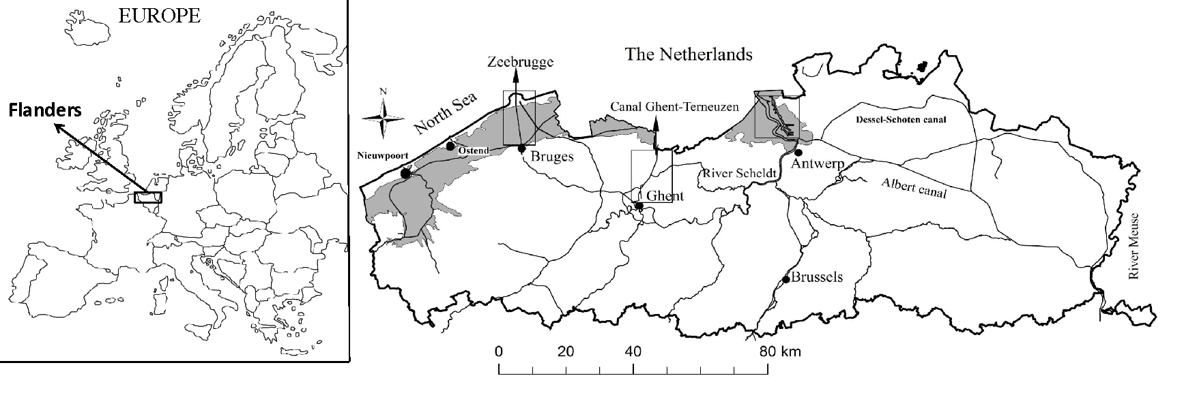Figure 1 Overview of the study area (Flanders, Belgium) with indication of the most important watercourses and geographical locations, an indication of the polder area (grey) and the three main harbours which are indicated by rectangles.

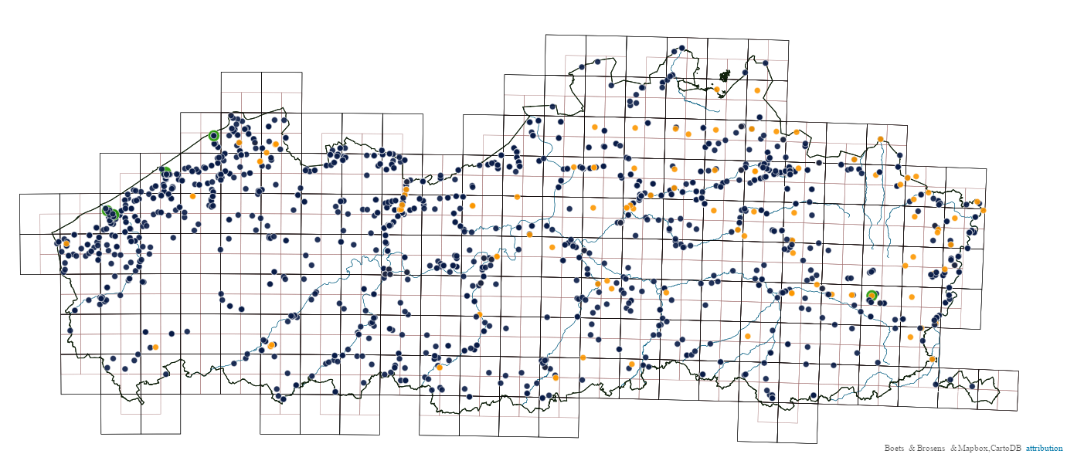
Figure 2 Sampling points for alien macroinvertebrates collected by the Flemish Environment Agency (black), authors (green), and colleagues (orange).

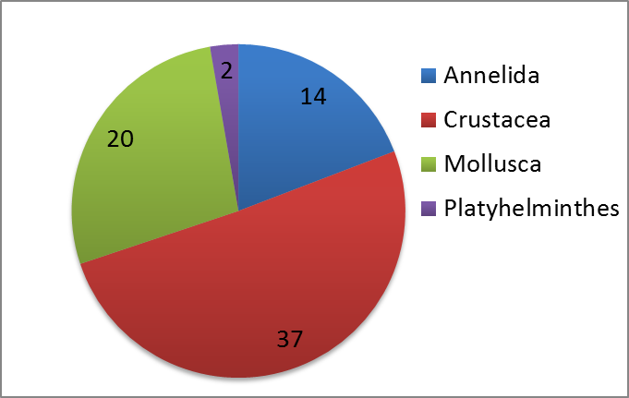
Figure 3 Pie chart representing the distribution of alien macroinvertebrates among the different phyla. Numbers indicate the actual number of species belonging to a certain phylum.

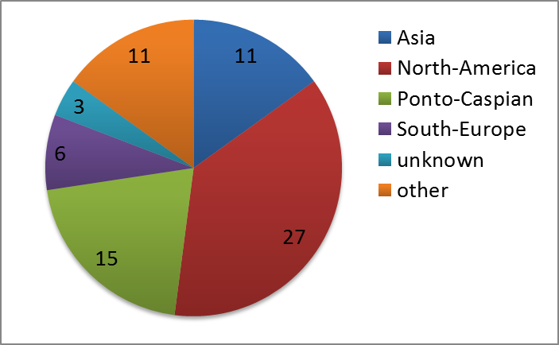
Figure 4 Pie chart representing the origin of the different alien macroinvertebrate species encountered in Flanders. Numbers indicate the actual number of species originating from a certain geographic region.

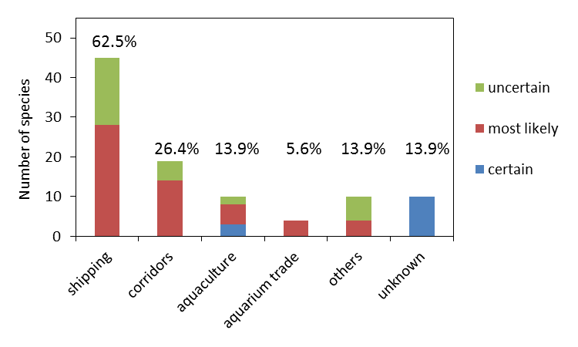
Figure 5 Number of alien macroinvertebrates introduced by each of the main pathways and its uncertainty (see main text for explanation). Percentages add to more than 100% as some species are related to several pathways.

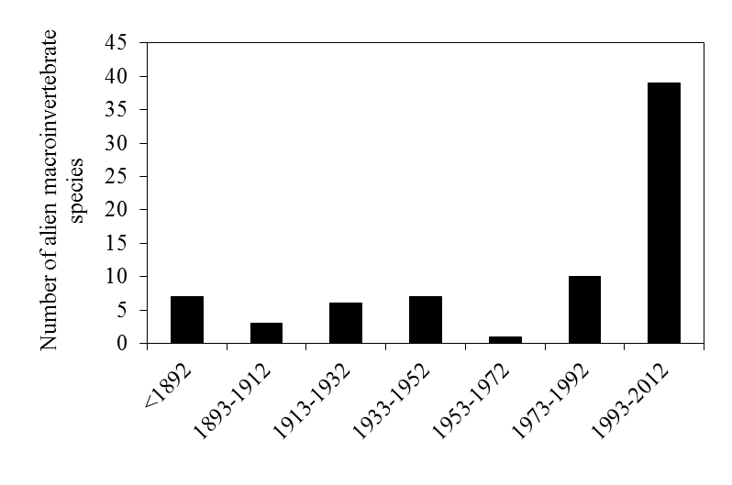
Figure 6 Number of established alien macroinvertebrate species in Flanders per twenty year time intervals.

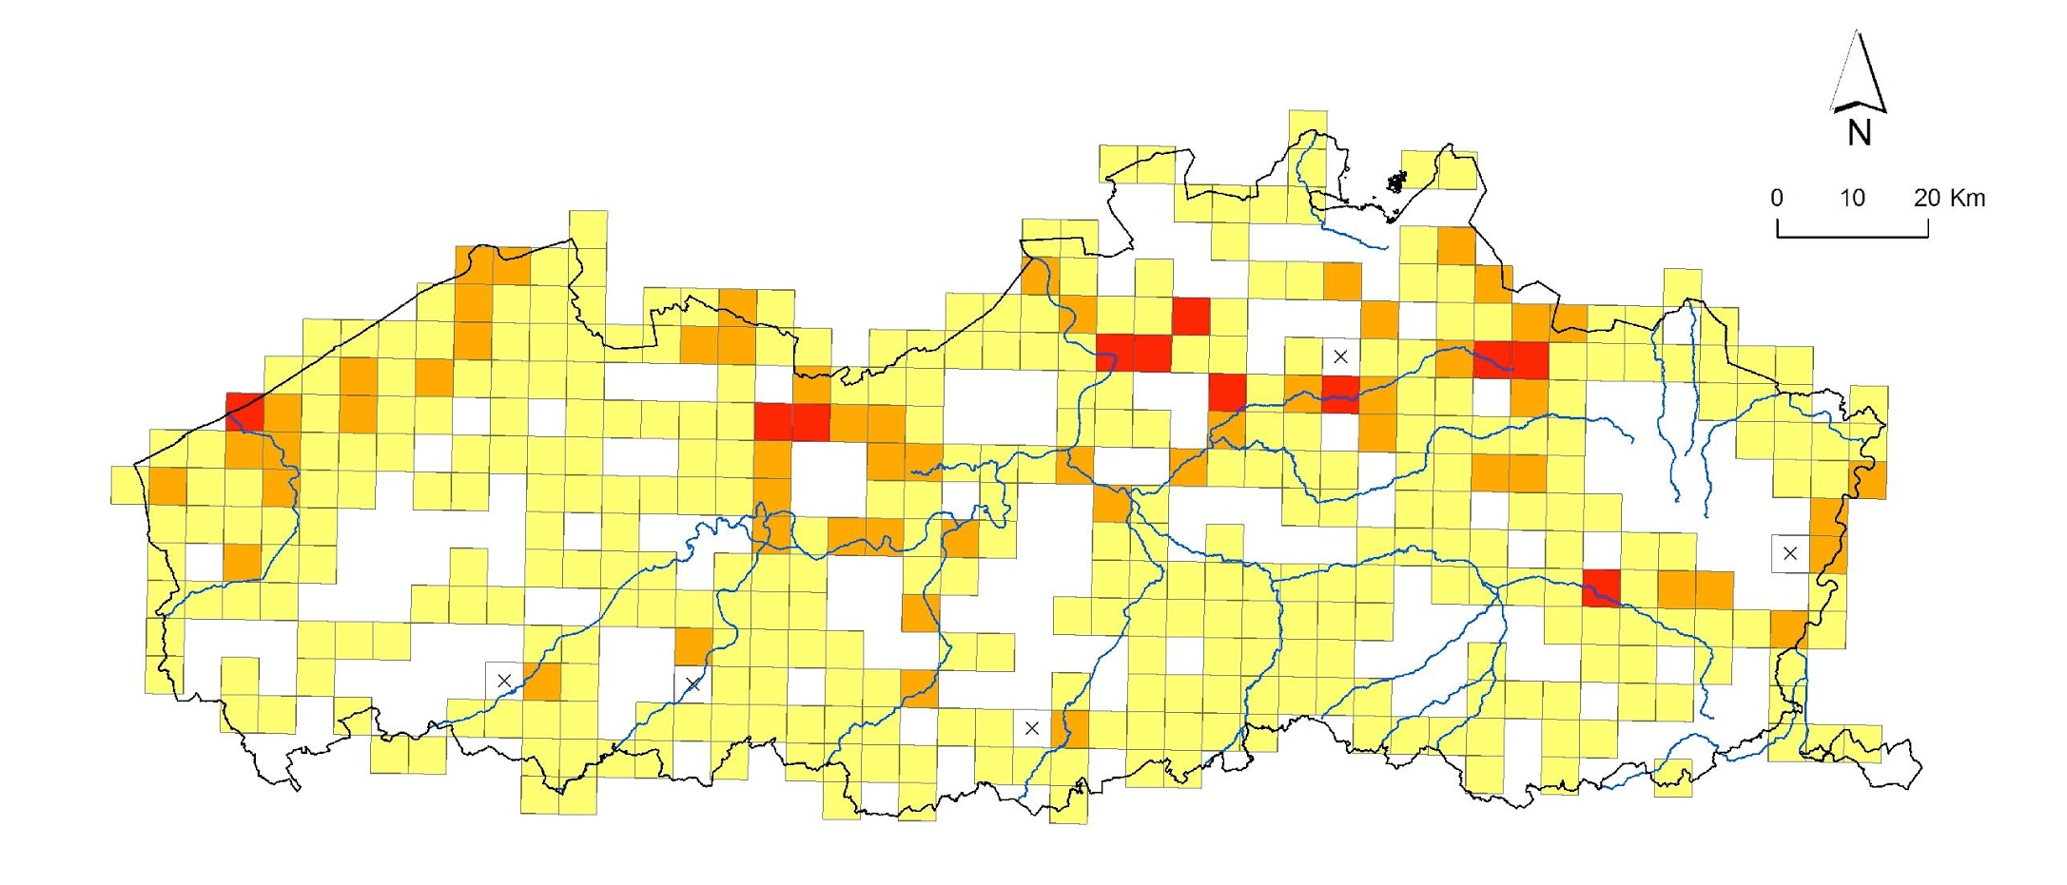
Figure 7 Map of Flanders indicating the number of alien macroinvertebrates species per 5 × 5 km² square. Legend: yellow= 1-5 species, orange= 6-10 species, red = 11-16 species. White squares indicate that there was no sampling data available, white squares with a cross indicate locations with no alien species recorded.

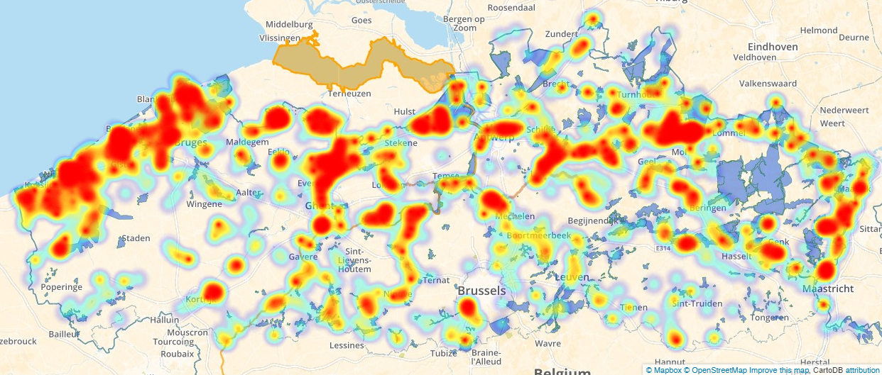
Figure 8 Heat map of all the alien macroinvertebrates in the published dataset. Red shapes indicate a high number of alien macroinvertebrate observations.

Supportive information – Appendix 1

Dataset
- Object name: Alien macro invertebrates in Flanders (Belgium)
- Character encoding: UTF-8
- Format name: Darwin Core Archive format
- Format version: 1.0
- Distribution: http://dataset.inbo.be/alien-macro-invertebrates-flanders-occurrences
- Publication date of data: yyyy-mm-dd of first publication
- Language: English
- Licenses of use: http://creativecommons.org/publicdomain/zero/1.0/
- Norms of use: https://www.inbo.be/en/norms-for-data-use
- Metadata language: English
- Date of metadata creation: yyyy-mm-dd of first publication
- Hierarchy level: Dataset

The Darwin Core terms (http://rs.tdwg.org/dwc/terms/) in the dataset at the time of publication are:
otherCatalogNumbers; rights; occurrenceID; scientificName; scientificNameAuthorship; verbatimTaxonRank; taxonRank; basisOfRecord; eventDate; recordedBy; identifiedBy;municipality; type; locality; decimalLatitude; decimalLongitude; geodeticDatum; verbatimCoordinates; verbatimSRS; coordinateUncertaintyInMeters; license; accessRights; RightsHolder; datasetID; datasetName; ownerInstitutionCode; countryCode; continent; kingdom; nomenclaturalCode
The data are dedicated to the public domain under Creative Commons Zero waiver. It would be much appreciated if you follow these norms (INBO 2015) for data use and notify the corresponding authors of the respective dataset if you use the data, especially for research purposes.

